The following reserved code values are used:
H214:
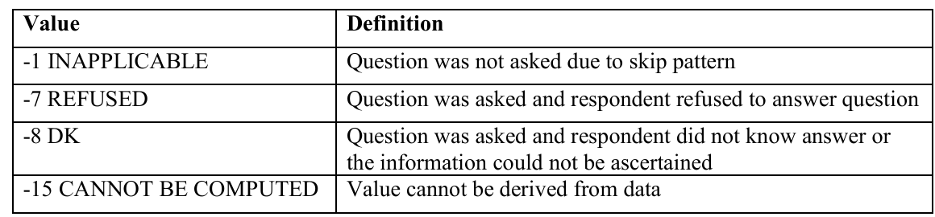

H216:
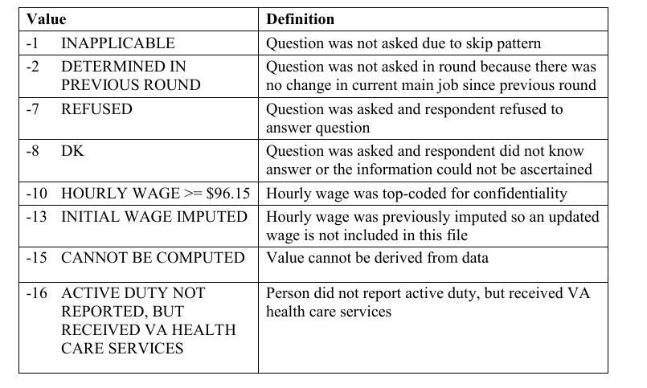

- 2.5.2.2 Age Priority Condition Began
The age of diagnosis (AGEDIAG) was collected for all priority conditions, except joint pain. For confidentiality reasons, AGEDIAG is set to Inapplicable (-1) for cancer conditions. To ensure confidentiality, age of diagnosis was top-coded to 85. This corresponds with the age top-coding in person-level PUFs.
- Total health expenditures

- REGION19

The round-specific variables REGION31, REGION42, REGION53, and the end-of-year status variable REGION19 indicate the Census region for the RU. REGION19 indicates the region for the 2019 portion of Round 5/3. For most analyses, REGION19 should be used.
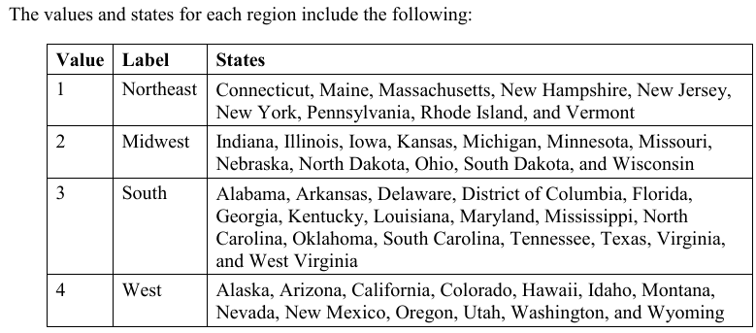
- Marital Status and Spouse ID
Current marital status was collected and/or updated during every round of the MEPS interview. This information was obtained in RE100 and RE1170 and is reported as MARRY31X, MARRY42X, MARRY53X, and MARRY19X. Persons under the age of 16 were coded as 6 “Under 16 – Inapplicable”. If marital status of a specified round differed from that of the previous round, then the marital status of the specified round was edited to reflect a change during the round (e.g., married in round, divorced in round, separated in round, or widowed in round).
- Age
- Sex
- Health Status Variables (IADLHP31-ADOVER42)

